Please send this application to WT Education dept. via email to (registration@worldtaekwondo.org)
by no later than August 25, 2023
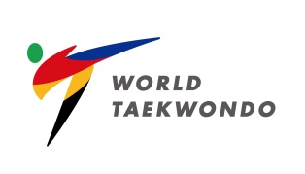 | Please send us your ENGLISH CV (separately) via email to  registration@worldtaekwondo.org
Name | Last Name: (Family) | First Name:
Residence | (Which MNA or CU belongs to) | Date of Birth | (DD/MM/YEAR)
Nationality |  | GOL Number
Position | (From your Pertinent MNA or CU)
Mobile Number | (Including national code)
E-mail
Recommendation by  President of pertinent Member National Associations or Continental Unions | Name: | Signature:
I hereby submit my application to attend the:
Level I / 2023 WT Online Technical Delegate Certification Course (Level I) – Kyorugi (9-10 September 2023)
Date:
Signature:

